GPS detector AIS 140

(Market size 4.3 inch and price vary from 4000 to 6000)

1. SIM 800L

Comparison between SIM800L and SIM800C

**Built-in RF Connector:** SIM800C comes with a built-in RF connector for an external antenna, making it more convenient to connect an antenna directly to the module.

**Relatively Larger Size:** SIM800C is slightly larger compared to SIM800L, with a size of around 24mm x 24mm x 3mm (L x W x H).

**Lower Power Consumption:** SIM800C is designed with a focus on lower power consumption, which can be advantageous for battery-powered applications or projects with limited power resources.id for AIS 140 compliance and other necessary certifications for use

**SIM 800L**

* Price 250-350
* Chip: SIM800L; Voltage: 3.7-4.2V; Peak Current: 2A; Supply voltage: 3.8V – 4.2V; Recommended supply voltage: 4V; Interface: UART (max. 2.8V) and AT commands; SIM card socket: microseism (bottom side); Supported frequencies: Quad Band (850 / 950 / 1800 /1900 MHz)
* Power consumption:- sleep mode < 2.0mA; idle mode < 7.0mA; GSM transmission (avgas): 350 mA; GSM transmission (peek): 2000mA; Antenna connector: IPX; Status signaling: LED; Working temperature range: -40 do + 85 ° C
* Module Size:- Length: 24mm; Width: 26mm; Height: 4mm; Weight: 12gm
* Package Includes:- 1 x SIM800L GPRS GSM Module Micro SIM Card Core Board Quad-band TTL Serial Port ( 3.7-4.2V); 1 x Antenna

**Availability**

1[. https://www.electronicscomp.com/sin800l-gsm-gprs-module-quad-band-ttl-board?gclid=Cj0KCQjw_O2lBhCFARIsAB0E8B9ftwQQIKpclb3ijhAGN3NEmp5Fs39EKAx_WRN1YgCqoBF_J_DU8_YaAqnFEALw_wcB](.%20https://www.electronicscomp.com/sin800l-gsm-gprs-module-quad-band-ttl-board?gclid=Cj0KCQjw_O2lBhCFARIsAB0E8B9ftwQQIKpclb3ijhAGN3NEmp5Fs39EKAx_WRN1YgCqoBF_J_DU8_YaAqnFEALw_wcB)

2. <https://robu.in/product/small-sim800l-gprs-gsm-module-micro-sim-card-core-board-quad-band-ttl-serial-port-antenna/?gclid=Cj0KCQjw_O2lBhCFARIsAB0E8B9X2X464fz5vUx4bWivCMrRWwMwrC9hf8LI0MB__yOpBMa6KOgQxuYaAhvIEALw_wcB>

**Quectel L89**

Dimensions 26.4 mm × 18.4 mm × 6.8 mm

Weight Approx. 8.2 g

GNSS Features Supported Bands

GPS/QZSS L1 C/A: 1575.42 MHz

GLONASS L1: 1602.5625 MHz

Accuracy of 1PPS Signal

100 ns

TTFF (with EASY) - Cold Start: 15 s Warm Start: 5 s Hot Start: 1 s

Sensitivity Acquisition: -148 dBm Tracking: -165 dBm Reacquisition: -157 dBm

I/O Voltage Typ. 3.0 V

**Availability-**

1. [https://evelta.com/l89ha-gnss-module-irnss-enabled/?campaignid=19631771445&adgroupid=&network=x&device=c&utm_source=19631771445&utm_medium=&gclid=Cj0KCQjw_O2lBhCFARIsAB0E8B8JqRJzgMXf75E-6E5IRkRoCoLWSV9XZVj7bPU99ahAJZJEnzFVl1gaAkYoEALw_wcB](%20https:/evelta.com/l89ha-gnss-module-irnss-enabled/?campaignid=19631771445&adgroupid=&network=x&device=c&utm_source=19631771445&utm_medium=&gclid=Cj0KCQjw_O2lBhCFARIsAB0E8B8JqRJzgMXf75E-6E5IRkRoCoLWSV9XZVj7bPU99ahAJZJEnzFVl1gaAkYoEALw_wcB)

2. <https://www.indiamart.com/proddetail/quectel-l89-gps-module-24804331855.html>

3. <https://www.mouser.in/ProductDetail/Quectel/L89-S90?qs=GedFDFLaBXECn3W%252BeFg0yQ%3D%3D>

**XL4015**

|  |  |
| --- | --- |
| Size | 5.4 X 2.3 X 1.5 cm |
| Output Voltage Range | 1.25-36 VDC |
| Output Current | 0-5 A |
| Output Power | 75 W |
| Efficiency | up to 96% |

* XL4015 Buck Converter IC – 1 45rs
* 78L05 Voltage Regulator – 1 8rs
* LM358 op-amp - 1 10rs
* SS54 Schottky Diode- 1 10rs
* TL431 Programmable Reference – 1 10rs
* 470uF,35V Capacitor - 2
* 10uF 0805 Capacitor -2
* 10K Ten Turns Trim Pot - 2
* 0.1uF Capacitor - 3
* 270R Resistor - 1
* 1K Resistor - 2
* 2.2K Resistor - 1
* 10K Resistor -  1
* 71.5K Resistor - 1
* 90.9K Resistor - 1
* LED 0805 - 3
* Screw Terminal - 2

**Availability**

**1.** [**https://www.dnatechindia.com/xl-4015-dc-to-dc-converter-ic.html**](https://www.dnatechindia.com/xl-4015-dc-to-dc-converter-ic.html)

**2.** [**https://www.electroncomponents.com/TL431-Adjustable- Programmable-Precision-Shunt-Regulator#:~:text=%E2%82%B920.00%20(%2B%20GST)**](https://www.electroncomponents.com/TL431-Adjustable-%20%20%20%20Programmable-Precision-Shunt-Regulator#:~:text=%E2%82%B920.00%20(%2B%20GST))

**ESP32 (6×6 mm² or 5×5 mm²)**

1. ESP32-D0WD-V3 embedded, Xtensa dual-core
2. 32-bit LX6 microprocessor, up to 240 MHz
3. 448 KB ROM for booting and core functions
4. 520 KB SRAM for data and instructions
5. 16 KB SRAM in RTC
6. Wi-Fi 802.11b/g/n  
   Bit rate: 802.11n up to 150 Mbps

**Availability**

[**https://www.electronicscomp.com/espressif-esp32-wroom-32e-4m-32mbit-flash-wifi-bluetooth-module?gclid=Cj0KCQjw_O2lBhCFARIsAB0E8B9jhfudNwbD0umbUcmrExwBt7VA41ZZukWpg0rhO9o9obzSyGp0bPQaAh8sEALw_wcB**](https://www.electronicscomp.com/espressif-esp32-wroom-32e-4m-32mbit-flash-wifi-bluetooth-module?gclid=Cj0KCQjw_O2lBhCFARIsAB0E8B9jhfudNwbD0umbUcmrExwBt7VA41ZZukWpg0rhO9o9obzSyGp0bPQaAh8sEALw_wcB)

**Micro SD card**

In this we use two capacitor and four resistors

Pull up and Pull down Resistance = 10k

Decoupling Capacitor = 0.1uF

**CMD Line (Command Line)**: The CMD line is used for command transmission from the microcontroller to the microSD card. This line is typically pulled-up using a resistor to ensure that the microSD card starts in a known state. A common value for the pull-up resistor on the CMD line is around 10kΩ. However, some microSD card modules may have internal pull-up resistors on the CMD line, eliminating the need for an external one.

**Chip Select (CS) Line**: The Chip Select line is used to enable or disable communication with the microSD card. It is often pulled high (active low) to disable the microSD card initially. When the microcontroller wants to communicate with the microSD card, it pulls the CS line low to enable the card for communication. The value of the pull-down resistor on the CS line is typically around 10kΩ.

**Availability**

1. <https://makeradvisor.com/tools/sd-card-module/>

Flow chart of code and important line

1. In this we will have to use two IP addresses

In case of emergency alert, the alert message shall be sent to 2 different IP addresses hence the device shall support minimum 2 IP addresses (1 IP address for regulatory purpose (PVT data) and 1 IP address for Emergency response system other than the IP’s required for Operational purpose.

2. SMS Fall Back

In case of emergency state, (i.e. on pressing of Alert button), the device will shift to the SMS mode in case GPRS connectivity is not available. In such case, the device will send the Alert message and tracking data through SMS mode. Since SMS has the limitation of sending only 160 characters, so the tracking data to be sent in one SMS will have fields - IMEI, Latitude, Direction, Longitude, Direction, location fix, speed, Cell

3. Message alert from device

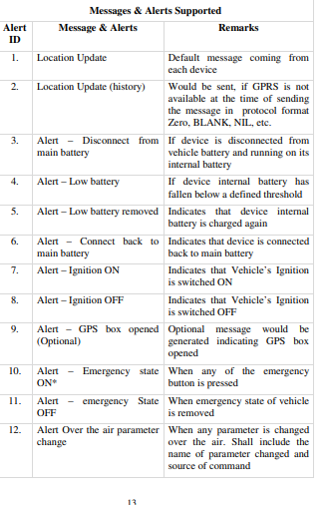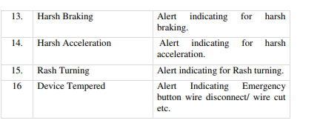

4. Health Monitoring parameter

The device shall send status of health parameters at configurable interval and this threshold value shall also be configurable over the air.

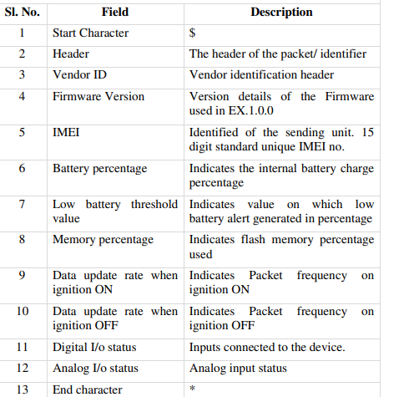

5. Message format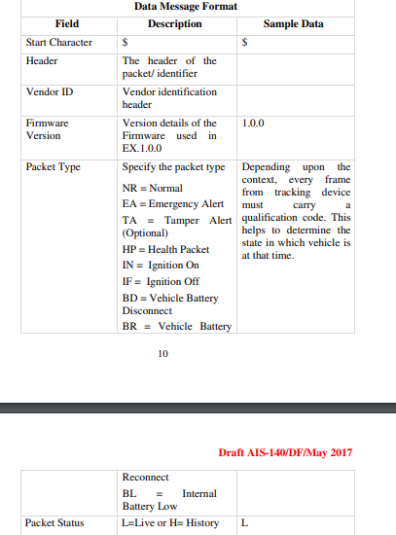

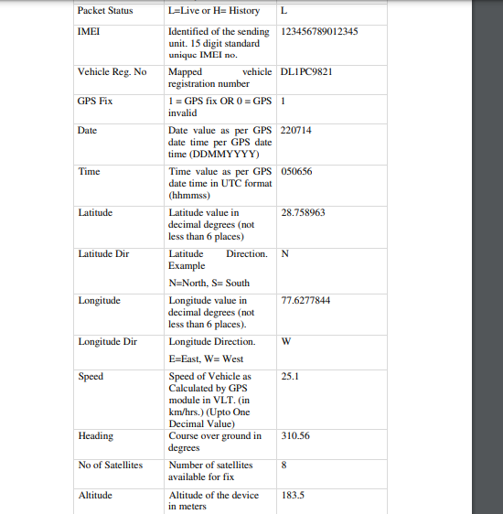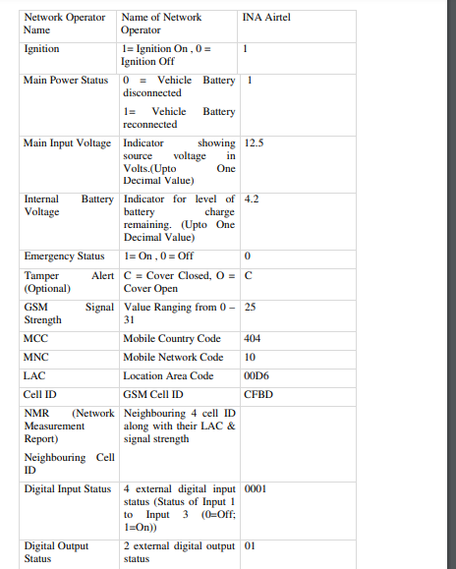

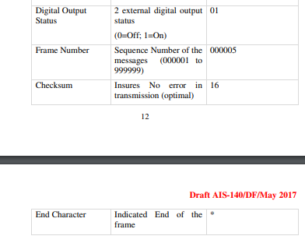

Testing of Configuration of Device Parameters Over the Air (OTA)

The following testing will be done for

1. Setting/ Change of the Primary or Secondary IP and port number

2. Setting/ Change of the APN

3. Set configuration, parameter like sleep time for speed, harsh braking, rash turns, etc.

4. Emergency SMS Centre Number

5. Configuring the vehicle registration number

6. Configuring the frequency of data transmission in normal / Ignition state / OFF state sleep mode, Emergency state, etc.

7. Configuring the time duration for Emergency state

8. Capability to reset the device

9. Command to get the IMEI of the device Configurable commands must involve the following features:

• SET: For setting the parameters.

• GET: For enquiring regarding the parameters such as mobile number, GSM strength, vehicle number and other important parameters.

• CLR: For clearing certain commands, alarms, alerts etc.

Electrical Wiring

The wiring harness used in the device shall be tested for flammability as per IS 2465.

Physical Mounting

The VLT system shall be mounted in a suitable location such a way that it is not easily accessible /exposed to passengers. This requirement shall not be applicable in case of combined systems VLT with HMI (Human Machine Interface) display in front of driver.

Test agency to verify this on vehicle level approval.

Emergency button(s) shall be fitted in such a way that every passenger including driver shall be able to access the Emergency button(s).

Passenger Car shall have 2 emergency buttons on each passenger row easily assessable by each of the passenger.

There shall also be one dedicated emergency button for the driver.

Passenger Transport bus shall have emergency buttons at locations easily visible & assessable to all the passengers such as every 2 meters on both the sides on passenger seating area.

For seats reserved for ladies there shall be a dedicated panic button for each row

Battery backup code to switch alternative battery

The vehicle tracking device will be installed on vehicles in which the power supply voltage from vehicle battery is widely varying (12V, 24V etc.) and also the power supply is not as stable as that in case of fixed locations, especially during engine start-up and braking when the voltage can fall to as low as 9V. Typically electronic devices are very sensitive to power surges and spikes, and equipment may fail if they do not receive stable power supply. The devices will need to have a resilient power supply unit that can withstand such fluctuations and the devices also need to have power backup so that they continue to function for some duration when the vehicle battery is not functional or is disconnected from the devices. Vehicle power interface shall have

• One common ground linked to vehicle chassis

• One permanent power Supply (12/24V) connected to the vehicle battery

• One non-permanent power line (12/24V) connect to the battery after ignition

Backend Control Centre

The following mandatory provisions will have to be made in the Backend Control Centre:

1. Registration and activation of the device(s) fitted on the vehicle, including the details of vehicle registration number, engine number, chassis number, vehicle make and model, device make and model, and telecom service provider’s name.

2. Re-registration/re-activation of the device(s) fitted on the vehicle in case of any change in device or telecom service provider, etc.

3. Administration/configuration of devices for any changes in the parameters as decided by the respective state from time to time.

4. Notification of alerts in case of press of an Alert Button fitted on the vehicle

5. Notification of alerts in case of defined deviations by vehicle such as over-speeding, deviation from defined route/geographic area, time of operation, etc.

6. Location tracking of the vehicle including real-time as well as history tracking for up to last 90 days.

7. Notification to the permit-holder through SMS in case any device(s) stops functioning/sending data to the Backend Control Centre.

8. Reports of the vehicles with devices not working/sending data beyond defined number of days (1 day, 3 days, 7 days and 30 days).

9. Ensure that the security and privacy of the data is maintained in accordance with applicable laws/guidelines of various government authorities.